Glen Trim
July 10, 1909 – October 7, 1931

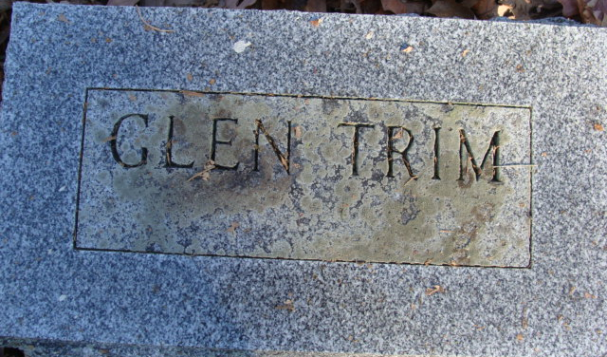
Photo by Alicia Kneuss

Glen Trim
in the Indiana, U.S., Death Certificates, 1899-2017
Name Glen Trim
Gender Male
Race White
Marital Status Married
Age 21
Birth Date 10 Jul 1909
Birth Place Indiana
Death Date 7 Oct 1931
Death Place Fort Wayne, Allen, Indiana, USA
Death Registration Date 1931
Father Frank Trim
Mother Dessie Fisher
Spouse Clara
Informant None listed
Burial October 10, 1931; Decatur, Indiana

