Frank Marion Trim
March 1, 1879 – March 28, 1956

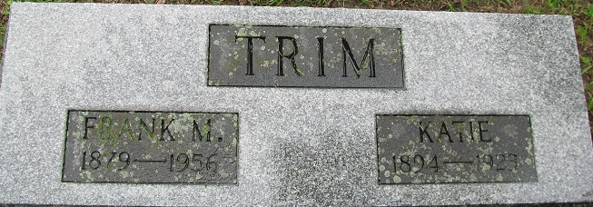
Photo by PLS

Former Decatur Man Dies At Fort Wayne
Frank M. Trim Dies After Long Illness
Frank M. Trim, 77, native of Pleasant Mills and a former resident of Decatur, died Wednesday at his home in Fort Wayne after an illness of six years. He had resided in that city for the past 50 years.
Mr. Trim was a yard conductor for the Pennsylvania Railroad 36 years until retiring in 1944. He was a member of the United Brethren Church and the Brotherhood of Railway Trainmen.
Surviving are his widow, Sadie M.; four sons, Don V., Victor V., and Leo R. Trim, all of Fort Wayne, and Edgar V. Trim of Elkhart: four daughters, Mrs. Mildred Patten of Fort Wayne, Mrs. Eddice Buelow of Wilmington, Del., Mrs. Flora May McCallister of Kentland, and Miss Marcella Trim of Chicago: two stepsons, Orla and Ralph Heminger, both of Fort Wayne; a stepdaughter. Mrs. Ethel Rice of Fort Wayne; a brother, Thomas Trim of Sturgis, Mich.; 22 grandchildren; 12 great-grandchildren, and 33 step-great-grandchildren. Frank and Tom Fisher of this city are brothers-in-law.
Funeral services will be held at 10 a.m. Saturday in the C. M. Sloan & Sons Funeral Home, the Rev. R. E. Vance officiating. Burial will be in the Decatur Cemetery. Friends may call at the funeral home after 7 o'clock this evening.
Decatur Daily Democrat, Adams County, Indiana
Thursday, March 29, 1956
**
Francis (Frank) Marion Trim from tree vicki gedcom
Birth 1 Mar 1879 Adams, Indiana, USA
Marriage 1923 Adams, Indiana, USA
Residence 1942 Indiana, USA
Death 28 Mar 1956 Fort Wayne, Allen, Indiana, USA
Father Christian\Christopher Trim (1851-1883)
Mother Sarah Elizabeth Barnett (1851-1928)
Spouse Destina Katie Fisher (1879-1911)
Spouse Katie Reader (1894-1923)

