Destina (Fisher) Trim
June 13, 1879 – September 1, 1911

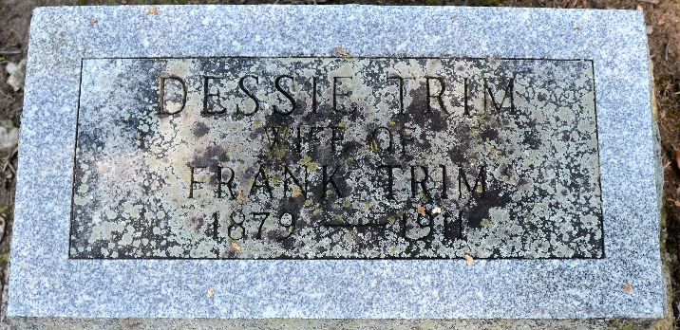
Photo by Deb Curry

Destina Trim
in the Indiana, U.S., Death Certificates, 1899-2017
Name Destina Trim
[Destina Fisher]
Gender Female
Race White
Marital Status Married
Age 32
Birth Date 13 Jun 1879
Birth Place Decatur, Indiana
Death Date 1 Sep 1911
Death Place Fort Wayne, Allen, Indiana, USA
Death Registration Date 1911
Father Clinton Fisher
Mother Yeager
Spouse Frank Trim
Informant Frank Trim; Fort Wayne, Indiana
Burial September 3, 1911; Decatur, Indiana

