Vivian M. (Riley) Tricker
September 27, 1922 – May 13, 2003

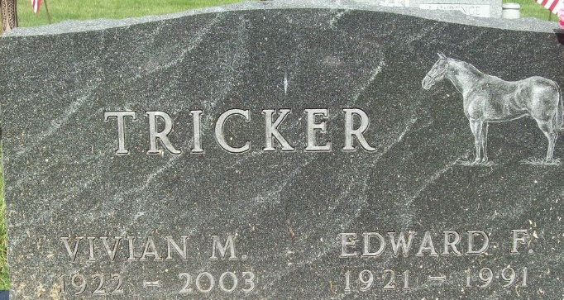
Photo by Alicia Kneuss

Vivian M. Tricker, 80, of 5900 W. Delaware County Road 350-N, died at 1:10 p.m. Tuesday in Ball Memorial Hospital. Mrs. Tricker was born in Adams County, Sept. 27, 1922, to the late Esther Mauller and R. Reed Riley.
She retired from Thunderbird Products, Decatur in 1984 after 13 years and was a member of Pleasant Mills United Methodist Church, Pleasant Mills, Ind.
Survivors include a son, Gene Tricker, Decatur; a daughter; Cundy (sic) Jackson ( husband Michael ), Muncie; a sister, Joan Johnson (husband John), Decatur; four grandchildren; and three great-grandchildren.
She was preceded in death by her husband, Edward F. Tricker, whom she married in Dec. 24, 1941, in Rockford Ohio. He died Sept. 36, 1991. Also preceding her in death were two brothers, Wayne and Robert Riley, and a sister, Neva Noll.
Services will be 11 a.m. Saturday in the Zwick and Jahn Funeral Home, Decatur, with Rev. Marvin E. Grooms officiating. Burial will follow at the Decatur Cemetery. Calling will be from 5 to 8 p.m. Friday and an hour before services Saturday at the funeral home.
Memorials may be sent to Pleasant Mills United Methodist Church, Pleasant Mills.

Zwick & Jahn Funeral Home, Adams County, Indiana
May 14, 2003

