Virginia Maxine Tricker
April 30, 1919 – August 5, 1927

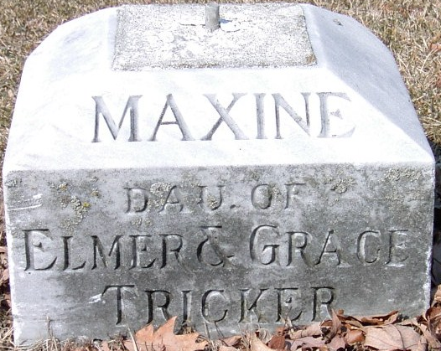
Photo by Trina

Tricker Child to be Buried Monday Morning
Funeral services for Maxine Tricker, age 9, daughter of Mr. and Mrs. Elmer Tricker, of Fort Wayne, who was fatally injured here yesterday morning when a railroad push pole fell across her stomach, will be held at the home of the child's uncle and aunt, Mr. and Mrs. Harry Coffelt, 310 Oak Street, at 9:30 o'clock and at the Presbyterian Church at 10 o'clock Monday morning. The Rev. Cecil R. Smith, pastor of the United Brethren Church, will officiate in the absence of the Rev. Harry Fernthiel, Presbyterian minister. Burial will be made in the Decatur Cemetery.
Decatur Daily Democrat; Adams County, Indiana
August 6, 1927
**
Indiana, U.S., Death Certificates, 1899-2017
Name Virginia Maxine Tricker
Gender Female
Race White
Marital Status Single
Age 8
Birth Date 30 Apr 1919
Birth Place Indiana
Death Date 5 Aug 1927
Death Place Decatur, Adams, Indiana, USA
Death Registration Date 1926-1927
Father Elmer Tricker
Mother Grace Coffelt
Informant Elmer Tricker; Decatur, Indiana
Burial August 8, 1927; Decatur Cemetery

