Jesse O. Tricker
December 18, 1889 – January 26, 1982

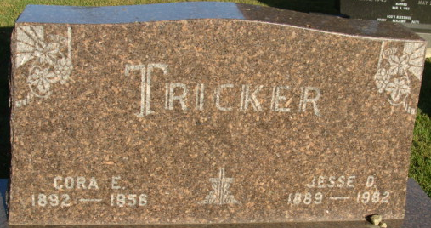
Photo by Alicia Kneuss

Jesse O. Tricker
in the Indiana, U.S., Death Certificates, 1899-2017
Name Jesse O. Tricker
Gender Male
Race White
Marital Status Widowed
Age 92
Birth Date 18 Dec 1889
Birth Place Indiana
Death Date 26 Jan 1982
Death Place Decatur, Adams, Indiana, USA
Death Registration Date 1982
Father George Tricker
Mother Sarah Robinson
Informant Byron Tricker; Atlanta, Michigan
Burial January 29, 1982; Decatur Cemetery; Decatur, Indiana

