Staff Sgt. Jack Lemoyne Tricker
July 21, 1921 – May 22, 1943

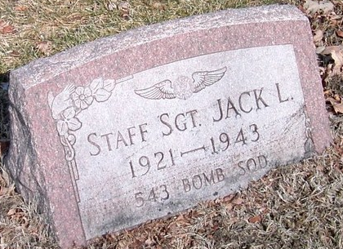
Photo by Trina

SGT. JACK TRICKER IS KILLED IN CRASH
Native of Decatur is Killed Saturday

Funeral services will be held Thursday afternoon for staff sergeant Jack Tricker, 23, a native of this city, who was killed Saturday night in an army bomber crash near Rapids City, South Dakota, according to word received here Sunday night. Sgt. Tricker, brother of Miss Betty Tricker, Central Sugar company employe, was an aerial gunner in a bomber crew. No details of the crash were learned.
He was born in this city, the son of Mr. and Mrs. Elmer E. Tricker, now living in Sturgis, Mich., and was graduated from the Decatur high school. Shortly after he was graduated his parents moved to Sturgis, and he enlisted in the army air force there in September. He had written to his parents to inform them that he would have a furlough, starting today and that he would arrive home soon after that time.
Surviving are the parents, Mr. and Mrs. Elmer E. Tricker of Sturgis; the grandmother, Mrs. Margaret Grimm of this city; the sister, Betty of Decatur; another sister, Sharon, at home, and two brothers, Richard and Kenneth, both of Fort Wayne. The body will arrive in Sturgis Wednesday night and services will be held there at 1 p.m. Thursday. The body will then be brought to Decatur and will arrive here sometime after 3 o'clock. Full military rites will be held at the burial site in the Decatur cemetery. The casket has been sealed at the camp site and will not be opened.

Decatur Daily Democrat, Adams County, Indiana
Monday, May 24, 1943
**

Funeral Rites for Sgt. Jack Tricker Changed to Friday

Funeral services for Sgt. Jack Tricker, former Decatur youth killed in a bomber crash in South Dakota Saturday night, have been changed from Thursday to Friday.
The services will be held Friday afternoon at 1 o’clock at the home of the parents, Mr. and Mrs. E. E. Tricker in Sturgis, Mich., and military rites will be held at the Decatur Cemetery between 3:30 and 4 o’clock the same afternoon.
Reports from Sturgis stated today that the body would not arrive there until Thursday night although it was expected tonight. The body was not released until last night, when an investigation into the crash of the ill-fated bomber was completed. Ten other soldiers died in the crash with Sgt. Tricker.

Adams County Historical Museum, Adams County, Indiana
January 1943 – July 1944, image 04-07
Handwritten date: Wednesday, May 26, 1943
**

Indiana, U.S., Birth Certificates, 1907-1944
Name Jack Lemoyne Tricker
Gender Male
Birth Date 21 Jul 1921
Birth Place Decatur, Adams, Indiana, USA
Father: Elmer Tricker; age 30
Mother: Grace Cauffelt; age 29; 5th child; all living
Certificate Number 35499
Roll number 40474_356371
Volume Range 67 - 72

