Grace A. (Coffelt) Tricker
February 8, 1893 – June 21, 1964

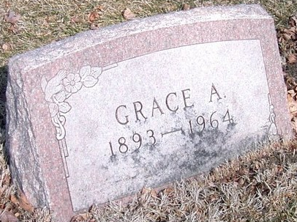
Photo by Trina

Grace Tricker
in the Michigan, U.S., Deaths and Burials Index, 1867-1995
Name Grace Tricker
Birth Date 8 Feb 1893
Birth Place Indiana
Death Date 21 Jun 1964
Death Place Sturgis, St. Joseph Co., Mich
Death Age 71
Race White
Marital Status Widowed
Gender Female
Father Name [William Henry Coffelt]
Mother Name Margaret Sudduth
Spouse Name Elmer Tricker
FHL Film Number 1940451
**
Indiana, U.S., Marriages, 1810-2001
Name Grace A Coffelt
Gender Female
Race White
Age 18
Event Type Marriage Registration (Marriage)
Birth Date 8 Feb 1893
Birth Place Adams, Indiana
Marriage Date 23 Dec 1911
Marriage Place Indiana, United States
Residence Place Decatur, Indiana
Father Henry Coffelt
Mother Margaret Sudduth
Spouse Elmer E Tricker
Page 193
FHL Film Number 002321467

