Gene F. Tricker
July 1, 1942 – April 26, 2016

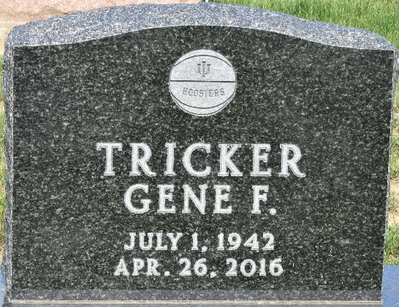
Photo by PLS

Gene F. Tricker, 73, Decatur, passed away Tuesday, April 26, 2016, at Lutheran Hospital in Fort Wayne. He was born in Adams County July 1, 1942, to the late Edward F. and Vivian M. (Riley) Tricker. He married Joann Reith March 30, 1986, in Fort Wayne; she preceded him in death April 28, 1988.
Gene was a member of Pleasant Mills United Methodist Church and the Moose Lodge 1311 of Decatur. He retired in 2003 after 37 years of service as a machinist at Phelps Dodge in Fort Wayne. Gene was a big IU basketball fan, NASCAR fan and loved to go out to eat.
Among survivors are his daughter, Michelle (Randy) Colclasure of Decatur; son, Tim F. Tricker of Decatur; sister, Cindy Jackson; two grandchildren, Dareck Colclasure and Krysten (Bryan) Drake; and four great-grandchildren, Chase, Brody, Kiera and Jordyn Colclasure.
Funeral services will be held at 10:30 a.m. Friday at Zwick & Jahn Funeral Home, with Pastor Ernie Suman officiating. Interment will follow in Tricker [sic] Cemetery. Visitation will be from 4-8 p.m. Thursday also at the funeral home.
Decatur Daily Democrat, Adams County, Indiana
April 27, 2016

