Elmer Edward Tricker
March 31, 1890 – February 1, 1963

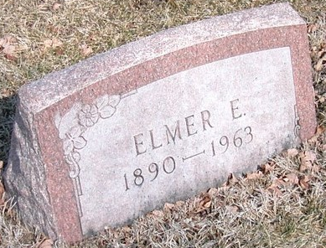
Photo by Trina

TRICKER, Elmer Edward, 72, 1650 S. Ft. Harrison Ave., Clearwater, Friday (Feb. 1, 1963).
Born in Decatur, Ind. Moved to Clearwater in November from Sturgis, Mich. Retired tire repair shop owner. Member First Presbyterian Church, Sturgis. Survived by his wife, Grace; a son, Richard H., Bloomington, Ind.; two daughters, Mrs. Sharon Kline, Ann Arbor, Mich., and Mrs. Betty Colchin, Kalamazoo, Mich.; two sisters, Mrs. Roy Young, Geneva, Ind., Mrs. Minnie Warner, Muncie, Ind., and four grandchildren.
Carl T. Bouchard Funeral Home, Largo, St. Petersburg, Florida
February 2, 1963
**
Tampa Bay, Florida, U.S., Obituary Index, 1855-2006
Name Elmer Edward Tricker
Age 72
Birth Date abt 1891
Death Date 1963
Obituary Date 3 Feb 1963
Obituary Place Florida, USA
Creator Tampa Tribune (Microfilm)
Page Deaths-P.A12
Subject Deaths
**
Elmer Edward Tricker from tree Anderson/Bush Family Tree
Birth 31 Mar 1890 Adams, Indiana, USA
Marriage 25 Jan 1912 Allen, Indiana, USA
Residence 1940 Sturgis, St Joseph, Michigan, USA
Death 1 Feb 1963 Clearwater, Pinellas, Florida, USA
Father Emanuel Tricker (1832-1916)
Mother Elizabeth Waller (1872-1937)
Spouse Grace Agnes Coffelt (1893-1964)

