Edward F. Tricker
June 25, 1921 – September 25, 1991

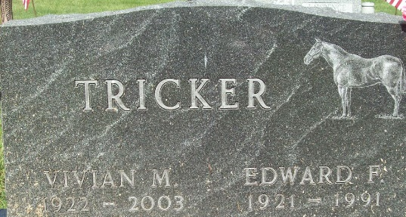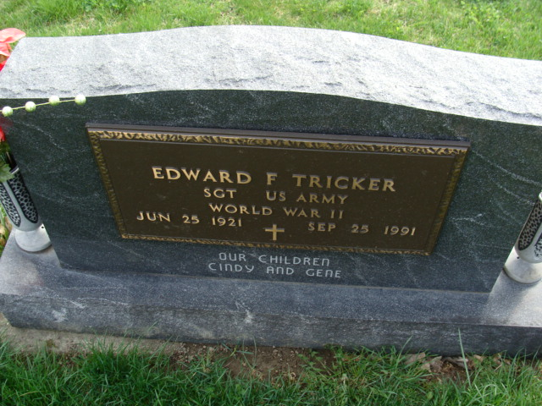
Photo by Alicia Kneuss

Edward F Tricker
in the Indiana, U.S., Death Certificates, 1899-2017
Name Edward F Tricker
Gender Male
Race White
Marital Status Married
Age 70
Birth Date 25 Jun 1921
Birth Place Rockford, Ohio
Death Date 25 Sep 1991
Death Place Muncie, Delaware, Indiana, USA
Death Registration Date 1991
Father Edwin Tricker
Mother Louise Ehrsam
Spouse Vivian Riley
Informant Vivian Tricker; wife; Muncie, Indiana
Burial September 28, 1991; Decatur Cemetery; Decatur, Indiana

