Cora E. (Daniel) Tricker
January 30, 1892 – July 24, 1958

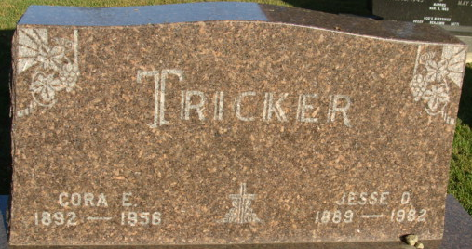
Photo by Alicia Kneuss

Mrs Cora Tricker
in the Indiana, U.S., Death Certificates, 1899-2017
Name Mrs Cora Tricker
[Mrs Cora Daniel]
Gender Female
Race White
Marital Status Married
Age 66
Birth Date 30 Jan 1892
Birth Place Indiana
Death Date 24 Jul 1958
Death Place Decatur, Adams, Indiana, USA
Death Registration Date 1958
Father Harvey Daniel
Mother Harriet Degamo
Informant J. O. Tricker; husband; Decatur, Indiana
Burial July 26, 1958; Decatur Cemetery; Decatur, Indiana

