Bruce Jay Tricker
December 14, 1949 – June 29, 1996

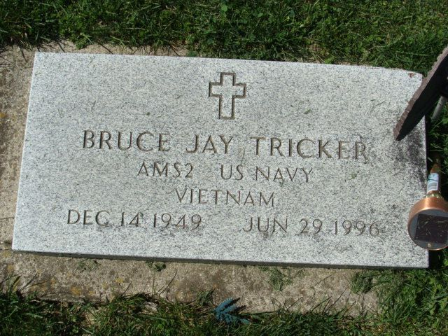
Photo by Alicia Kneuss

Bruce Jay Tricker, 46, of Decatur died Saturday in VA Northern Indiana Health Care System, Indianapolis. The Fort Wayne native retired in 1982 as a journeyman pipe rigger, construction worker and rigging foreman for Daniel International, and was a veteran of the Vietnam War.
Surviving is his stepfather, Carl L. Shaw; and brother, Jeffrey Stuart, both of Decatur.
Services, with a Veterans of Foreign Wars memorial, are 10 a.m. Wednesday in Zwick-Sefton & Jahn Funeral Home, Decatur, where calling is 9 to 10 a.m. Wednesday.
Memorials are to Lutheran Hospital dialysis unit.

News-Sentinel, Allen County, Indiana
Tuesday, July 2, 1996
**
Indiana, U.S., Death Certificates, 1899-2017
Name Bruce Jay Tricker
Gender Male
Race White
Marital Status Divorced
Age 46
Birth Date 14 Dec 1949
Birth Place Fort Wayne, Indiana
Death Date 29 Jun 1996
Death Place Indianapolis, Marion, Indiana, USA
Death Registration Date 1996
Father John Scolard
Mother Mary Jean Tricker
Informant Jeffrey Stuart; brother; Decatur, Indiana
Cremation July 2, 1996; Northern Indiana Crematory; Fort Wayne, Indiana

