Paul W. Tribolet
April 5, 1889 – July 11, 1948

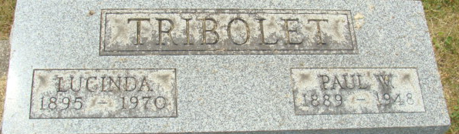
Photo by Alicia Kneuss

Paul W Tribolet
in the Ohio, U.S., Rutherford B. Hayes Presidential Center Obituary Index, 1810s-2016
Name Paul W Tribolet
Death Age 59
Birth Date abt 1889
Death Date 11 Jul 1948
Death Place Bellevue, Ohio, USA
Spouse Lucille
**
Paul Walmer Tribolet from tree Weiss Family Tree
Birth 5 Apr 1889 Bluffton, Wells, Indiana, USA
Marriage 22 Mar 1912 Hillsdale, Hillsdale, Michigan, USA
Residence 1 Apr 1940 Bellevue, Huron, Ohio, USA
Death 11 Jul 1948 Bellevue, Huron, Ohio, USA
Father Adolph Jacob Tribolet (1851-1936)
Mother Barbara A Walmer (1854-1912)
Spouse Lucinda Andrews (1895-1970)

