Jack Andrews Tribolet
October 10, 1927 – June 8, 1976

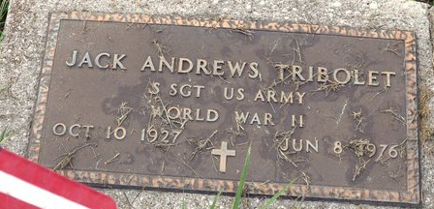
Photo by Deb Curry

Jack Andrews Tribolet
in the U.S., Headstone Applications for Military Veterans, 1861-1985
Name Jack Andrews Tribolet
Rank Staff Sergeant
Birth Date 10 Oct 1927
Service Number Ra 15403689
Service Branch US Army
Unit Infantry
Enlistment Date 11 Oct 1945
Discharge Date 10 Feb 1947
Death Date 8 Jun 1976
Cemetery Decatur Cemetery
Cemetery Location Decatur, Indiana, USA
**
California, U.S., Death Index, 1940-1997
Name Jack A Tribolet
[Jack andrews Tribolet]
Social Security # xxx
Gender Male
Birth Date 10 Oct 1927; Birth Place Ohio
Death Date 8 Jun 1976; Death Place Contra Costa
**
Jack Andrews Tribolet from tree Stephens
Birth 10 Oct 1927 Ohio, USA
Residence 1954 Los Angeles, Los Angeles, California, USA
Death 8 Jun 1976 Contra Costa, California, USA
Father Paul Walmer Tribolet (1889-1948)
Mother Lucinda Andrews (1895-1970)

