Lucinda (Andrews) Tribolet-English
March 25, 1895 – July 25, 1970

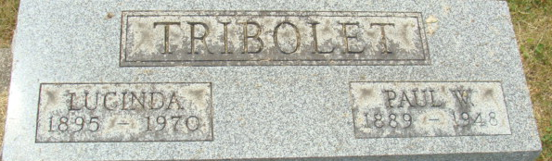
Photo by Alicia Kneuss

Andrews
in the Indiana, U.S., WPA Birth Index, 1880-1920
Name Andrews
Gender Female
Birth Date 25 Mar 1895
Birth Place Adams, Indiana, USA
Father C M Andrews
Mother Pease
Comment Handwritten Note Used
Book H-3; Page 33
**
Michigan, U.S., Marriage Records, 1867-1952
Name Lucinda Andrews
Gender Female
Race White; Age 18
Birth Date abt 1894
Birth Place Indiana
Marriage Date 22 Mar 1912
Marriage Place Hillsdale, Hillsdale, Michigan, USA
Residence Place Adams Co, Indiana
Father Cash Andrews
Mother Mary Pease
Spouse Paul Walmer Tribolet
Record Number 7410
**
California, U.S., Marriage Index, 1960-1985
Name Lucinda L Tribolet
Gender Female
Birth Year abt 1895
Age 67
Marriage Date 31 Mar 1962
Marriage Place San Mateo, California, USA
Spouse Name Virgil R English
Spouse Age 71
**
California, U.S., Death Index, 1940-1997
Name Lucinda English
Social Security # xxx
Gender Female
Birth Date 21 Mar 1895
Birth Place Indiana
Death Date 25 Jul 1970
Death Place Alameda
**
Lucinda "Lucille" Andrews (Tribolet) (English) from tree D'Augustine Family Tree
Birth 25 Mar 1895 Allen, Indiana, USA
Residence 1950 Bowling Green, Wood, Ohio, USA
Marriage 31 Mar 1962 San Mateo, San Mateo, California, USA
Death 25 Jul 1970 Alameda, California, USA
Father Cassius M "Cash" Andrews (1860-1934)
Mother Mary Lucinda Pease (Andrews) (1866-1923)
Spouse Paul Walmer Tribolet (1889-1948)
Spouse Virgil R English (Born 1891)

