Mildred (Dawson) Tribble-Vail
June 9, 1894 – December 1, 1980

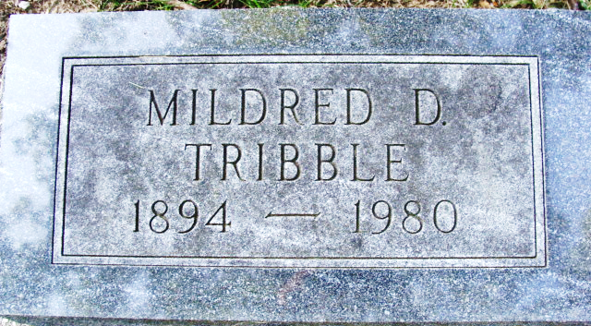

Mildred D Tribble
in the Indiana, U.S., Marriage Certificates, 1960-2012
Name Mildred D Tribble
Marriage Age 60
Birth Date 9 Jun 1894
Marriage Date 17 Sep 1954; Marriage Place Whitley, Indiana, USA
Spouse C Roy Vail
**
U.S., Social Security Death Index, 1935-2014
Name Mildred Tribble
Social Security Number xxx
Birth Date 9 Jun 1894
Issue year Before 1951; Issue State New Jersey
Last Residence 37421, Chattanooga, Hamilton, Tennessee, USA
Death Date Dec 1980
**
Georgia, U.S., Death Index, 1919-1998
Name Mildred D Tribble
Gender Female; Race White; Age 86
Birth Date abt 1894
Residence Place Bacon, Georgia, USA
Death Date 1 Dec 1980; Death Place Catoosa, Georgia, USA
File Date 8 Dec 1980
Certificate Number 040195

