Norma E. (Kimmey) Treon
April 4, 1916 – July 29, 2000

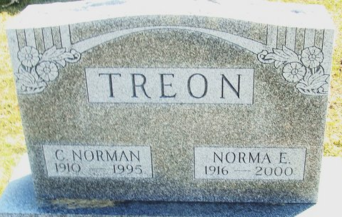
Photo by Deb Curry

Norma E. Treon, 84, of Decatur, a member of First Christian Church, died Saturday, July 29, 2000, at Adams County Memorial Hospital, Decatur.
The Van Wert County, Ohio, native was a homemaker and co-owner of Treon Poultry for 28 years before retiring in 1972.
Surviving are her daughter, Patricia L. Reichert of Decatur; a sister, Violet N. Fredericks of Lima, Ohio; three grandchildren; and two great-grandchildren. She was preceded in death by her brothers, Ronald, Ernest and Vernon Kimmey.
Services are 11 a.m. Tuesday at Haggard & Sefton Funeral Home, Decatur, with calling from 4 to 8 p.m. today. Burial will be at Decatur Cemetery.
News-Sentinel, Allen County, Indiana
Monday, July 31, 2000
**
Indiana, U.S., Death Certificates, 1899-2017
Name Norma E. Treon
[Norma E. Kimmey]
Gender Female
Race White
Marital Status Widowed
Age 84
Birth Date 4 Apr 1916; Birth Place Van Wert County, Ohio
Death Date 29 Jul 2000; Death Place Decatur, Adams, Indiana, USA
Father James O. Kimmey
Mother Nellie E. Click
Informant Patricia Reichert; daughter; Decatur, Indiana
Burial August 1, 2000; Decatur Cemetery; Decatur, Indiana

