Charles Norman Treon
June 11, 1910 – May 3, 1995

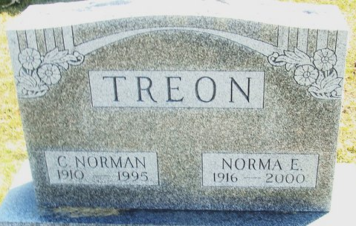
Photo by Deb Curry

Norman "Curley" Treon, 87, 357 Stevenson St., died at 6:30 a.m. Wednesday at home. He was born on November 11, 1910 in Versailles, Ohio to Charles W. and Lou Smith Treon and married Norma Kimmey on August 25, 1934. She survives.
He retired in 1972 after 28 years as owner of Treon's Poultry and was a member of Decatur Moose Lodge 1311. He was a former member of the United Church of Christ.
Other survivors are a daughter, Patricia Reichert, Decatur; three grandchildren and two great-grandchildren. A sister, Josephine J. Runkle, and a brother, Robert N. Treon are deceased.
Funeral services will be at 2 p.m. Saturday in Haggard and Armes Funeral Home, Decatur, with burial in Decatur Cemetery. Visiting hours are 2-5 and 7-9 p.m. Friday. There will be a Moose memorial service at 8 p.m. Friday.
Decatur Daily Democrat, Adams County, Indiana
Thursday, May 4, 1995
**
Indiana, U.S., Death Certificates, 1899-2017
Name Charles Norman Treon
Gender Male
Race White
Marital Status Married
Age 84
Birth Date 11 Jun 1910
Birth Place Versailles, Ohio
Death Date 3 May 1995
Death Place Decatur, Adams, Indiana, USA
Father Charles W Treon
Mother Lou Smith
Spouse Norma Kimmey
Informant Norma Kimmey Treon; wife; Decatur, Indiana
Burial May 6, 1995; Decatur Cemetery; Decatur, Indiana

