Walter Edward Trask
October 18, 1915 – February 2, 1999

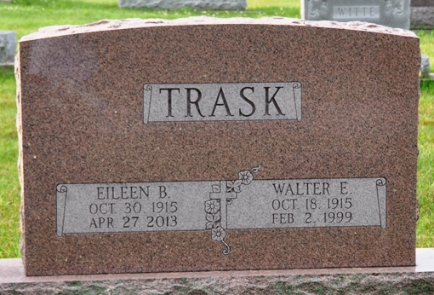
Photo by Deb Curry

Walter E. Trask, 83, of Cincinnati and formerly of Fort Wayne, died Tuesday, Feb. 2, 1999. Surviving are his wife, Eileen; a daughter, Frances Trask Chichester of Cincinnati; sons Michael W. McMillen of Atlanta, Ga., and Barry W. McMillen of Chisago City, Minn.; eight grandchildren; and seven great-grandchildren.
Memorial services are 1 p.m. Friday at First Wayne Street United Methodist Church, 300 E. Wayne St., Fort Wayne. There is no calling. Burial with private services will be Saturday at Decatur Cemetery, Decatur, Ind.
Memorials are to Moore-Trask Scholarship Fund, Indiana Institute of Technology, 1600 E. Washington Blvd., Fort Wayne or Hospice of Cincinnati, 4310 Cooper Road, Cincinnati, OH 45242. Information provided by the family.
News-Sentinel, Allen County, Indiana
Thursday, February 4, 1999
**
Ohio, Deaths, 1908-1932, 1938-1944, & 1958-2007
Name: Walter Edward Trask
Birth Date: 18 Oct 1915; Birth State: Michigan
Gender: Male; Race: White; Hispanic Origin: Not Hispanic (Latino) Residence County: Hamilton; Residence State: Ohio 45249
Death Date: 2 Feb 1999; Death Time: 05:20 AM; Age at Death: 83
Hospital of Death: Hospice of Cincinnati, Blue Ash, Hamilton, Ohio
Certificate: 012472; Registrar's Certificate Number: 00339
Certifier: Physician; Not Referred to Coroner; No Autopsy performed; Method of Disposition: Cremation
Filing Date: 5 Feb 1999; Hospital Status: Status Unknown;
Injury in Ohio: Yes; Type Place of Injury: Unspecified Place
Father's Surname: Trask; Mother's Maiden Name: Griffiths
Marital Status: Married; Education: 5+ years college
Armed Forces Indicator: No; Occupation of Decedent: Postsecondary teachers, subject not specified; Primary Registration District: 3112

