Eileen (Burk) Trask
October 30, 1915 – April 27, 2013

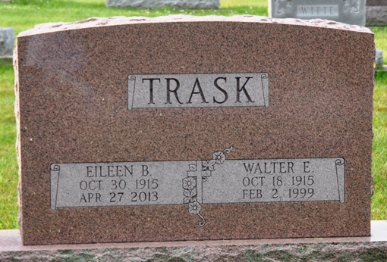
Photo by Deb Curry

Eileen Trask
in the U.S., Obituary Collection, 1930-Current
Name Eileen Trask
[Eileen Burk]
Gender Female
Death Age 97
Birth Date 30 Oct 1915
Birth Place Decatur, Ind.
Marriage Date 1947
Residence Place Ft. Wayne, Ind
Death Date 27 Apr 2013
Death Place Cincinnati, Ohio
Father Avon Burk
Mother Frances Burk
Spouse Walter E. Trask
Child Barry McMillen, Cary Chichester, Michael McMillen,
Frances
Siblings James Burk

