Ruth (Parsons) Townsend
September 4, 1892 – May 19, 1979

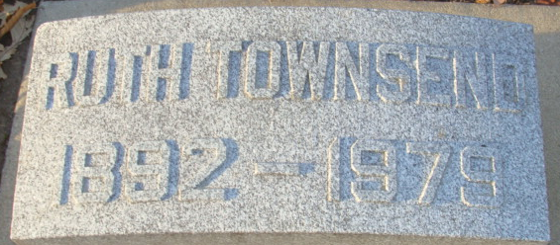
Photo by Alicia Kneuss

Ruth P Townsend
in the Indiana, U.S., Death Certificates, 1899-2017
Name Ruth P Townsend
[Ruth P Parsons]
Gender Female
Race White
Marital Status Widowed
Age 86
Birth Date 4 Sep 1892
Birth Place Illinois
Death Date 19 May 1979
Death Place Decatur, Adams, Indiana, USA
Death Registration Date 1979
Father Dr George Fletcher Parsons
Mother Jospehine Booth
Informant Mrs. Corolene Allwein; Decatur, Indiana
Burial May 22, 1979; Decatur Cemetery; Decatur, Indiana

