Dick Townsend
November 6, 1860 – March 11, 1919

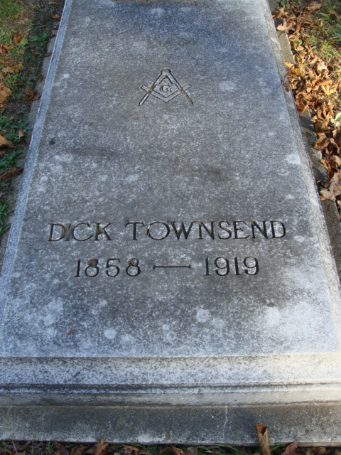
Photo by Alicia Kneuss

Dick Townsend Dies at Chicago, Ill
Noted Hotel Man and Former Manager of Randall Succumbs to Illness
Dick Townsend nationally known as a Hotel man of prominence and formerly manager of the Randall House of this city, died at ll o'clock yesterday morning at his apartment on Harper Ave, Chicago. Announcement of his death was received yesterday by friends both here and in Decatur. Suffering from a nervous breakdown (some time?) ago, Mr. & Mrs. Townsend went to Chicago where he could receive treatment from a specialist. He later suffered from a severe cold, a relapse setting in and his condition gradually becoming weaker until his death.
Mr. Townsend who was 53 years of age was a native of Adams Co and was born in Monmouth, Ind. He was acclaimed throughout the US as one of the best known hotel managers in the country. He started in the business at Decatur when he was (?) with his grandfather in the old Burt House where he worked his way up until he became the manager. Coming to Ft Wayne from Decatur about (?) he assumed management of the Randall House which under the 8 years of his skillful management became one of the most popular hotels the city has ever had. He was also at one time head of the Oliver Hotel at South Bend, the National at Peoria, Ill., the Great Northern Chicago, and popular hotels in Indianapolis, Kansas City, Paducah, Ken and other places.
His health beginning (to fail to fall?) about a year (after?) (when?) he retired from the business and he and his wife formerly Miss Iantha Gregory made their home at Decatur. Mr. Townsend was a prominent member of the Masonic Fraternity and had attained to 32nd degree in the Scottish rite.
He is survived by the widow, one son Burt of Chicago, a sister Miss Maggie Jeffery (M____--may say Missouri). The body will arrive at Decatur Thursday over the Erie Railroad and will be taken to the family home on Madison Street. Funeral arrangements have not yet been made.

Journal Gazette, Allen County, Indiana
March 12, 1919
**
Dick Townsend
in the Illinois, U.S., Deaths and Stillbirths Index, 1916-1947
Birth Date 6 Nov 1860
Birth Place Monmouth, Ind
Death Date 11 Mar 1919
Death Place Chicago, Cook, Illinois
Burial Date 13 Mar 1919
Burial Place Decatur, Ind.
Death Age 58
Occupation Hotel Proprietor
Race White
Marital Status M
Gender Male
Street Address 515 Madison St.
Residence Decatur, Ind.
Father Name Eli Townsend, b. N.Y.
Mother Name Leokada Burt, b. N>Y>
Spouse Name Cordel... Townsend
Comments Resident of City 4 months.
FHL Film Number 1852715
**
Decatur is the home of one of the most widely known hotel men in the Middle West. Dick Townsend has been in the hotel business almost continuously since he was eighteen years of age. Some of his earliest experiences were gained in Decatur. He went from this city to some of the largest cities in the country and some of the finest hotels, and it is doubtful if any resident of Indiana knows more about the ins and outs and the technical and practical details of hotel management than Dick Townsend.
Mr. Townsend claims Adams County as his birthplace. He was born in Root Township in 1860, grew up in the county, attended St. Mary's parochial schools and also graduated from the city high school at Decatur. His first employment was with the old Burt Hotel at Decatur, where he worked as a bell hop and as a bus driver. After a few years he was promoted to the management of this old time hostelry, and he was at its head for fifteen or twenty years and during that time greatly improved its facilities, added to its comforts and made it one of the leading houses for the entertainment of the traveling public in this section of the state. In the meantime for seven years the Randall House at Fort Wayne, owned by Perry A. Randall, enjoyed its greatest period of prosperity under Dick Townsend's management. Mr. Randall paid him a large salary for those days to manage this house.
In 1897, leaving Fort Wayne, and selling his interests at Decatur, Mr. Townsend took the management during 1897-98 of the Grant Hotel at Minneapolis. The owner of this property was Tom Taggart, whose enterprise made West Baden one of the most famous resorts in America and who for years has been the democratic chieftain of Indiana. While at the Grant, Mr. Townsend served the first buffet luncheon that was ever a formal part of a hotel service west of New York City. The service was carried out with great eclat and success and was given for the special benefit and entertainment of democratic friends of Tom Taggart who were visiting Indianapolis from Chicago.
After his experience at the Grand in Indianapolis, Mr. Townsend returned to Decatur and again assumed the management of the Burt Hotel, being with it until it burned down in 1906. He was then with the National Hotel of Peoria, Illinois, until that structure was destroyed by fire in 1911. This fire caused a personal loss to Mr. Townsend of $46,000 and was the worst disaster he has ever had in his entire business experience. The following year he spent in Kansas City operating the Stockyards Hotel. He then managed the Oliver Hotel at South Bend, Indiana, and for a few months had charge of the Ebbitts House at Washington, D.C., was manager of the Palmer House at Paducah, Kentucky, and until June 1917, was head of the Great Northern Hotel at Chicago. At that date he retired at least temporarily from the hotel business and came back to his old town and his old friends at Decatur.
Mr. Townsend's grandfather, Rufus Townsend, who was born in New York State, was one of a family of fourteen brothers, was engaged in business for many years as a hop grower in Albany County, New York. He died at Rensselaerville in that state at the age of ninety-four. His son Eli Townsend, father of Dick Townsend, was one of three children and was born in Albany County. Quite early in life he went into the show business as an actor and spent many years traveling about over the country. While on the road he met and married Lea Katie Burt, a native of New York State.
In her day she was one of the best-known stage dancers of the country. After their marriage they continued the stage for a number of years. Eli Townsend died at his father's home in Albany County, New York, in 1866.
His widow survived him more than half a century, passing away at Fort Smith, Arkansas, in March 1917, when about eighty years of age. She died at the home of her daughter, Mrs. Maggie Jeffries. Her father, Chester Burt, is well remembered by Adams County people. He was born in Chenango County, New York, and for many years was on the road as a showman. Late in life he came to Decatur, Illinois(sic), and became proprietor of the hotel which bore his name until it was burned on Christmas Eve, December 24, 1906, while his son-in-law Mr. Townsend was in charge. Chester Burt died during the early '70s. He was born about 1800. At Decatur he became one of the organizers of the Masonic Lodge and was also known as a stanch democratic voter.
Dick Townsend first married Jessie L. Allison. By that marriage he had one son, Burt Allison Townsend, who was born at Decatur about thirty years ago. He finished his education in the Howe Military School and held the rank of lieutenant and captain. At one time he was clerk in the Claypool Hotel at Indianapolis, and for a number of years has followed the example of his father and has been active in hotel work. Burt A. Townsend married Ruth Parsons, daughter of a well-known physician of Chicago now deceased. They have two young children: Dick Allison, three years old. and Burt Parsons, born in 1916.
Mr. Dick Townsend married for his present wife Iantha C. Gregory. She was born at Decatur in 1872 and is a graduate of the Decatur High School, after which for several years she was a clerk in the old Adams County Bank. Her parents were A. C. and Lucy (Burt) Gregory, native of New York State, but they married at Decatur, where her father for a number of years was a painter and house decorator. Her parents died in this city when about sixty-eight years of age. Her father was a republican and a Thirty-second degree Mason.
Mr. Townsend is a charter member of the Masonic Lodge of Decatur, is affiliated with the local Royal Arch Chapter, with the Fort Wayne Commandery of Knights Templar and with the Indianapolis Consistory of the Scottish Rite.
Standard History of Adams and Wells Counties, Indiana; Lewis Publishing Company, 1918

