Cordelia I. (Gregory) Townsend
March 11, 1872 – June 28, 1963

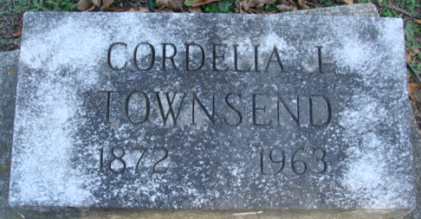
Photo by Alicia Kneuss

Cordelia I Townsend
in the Indiana, U.S., Death Certificates, 1899-2017
Name Cordelia I Townsend
[Cordelia I Gregory]
Gender Female
Race White
Marital Status Widowed
Age 91
Birth Date 11 Mar 1872
Birth Place Indiana
Death Date 28 Jun 1963
Death Place Decatur, Adams, Indiana, USA
Death Registration Date 1963
Father Agustus Gregory
Mother Lucy Woodruff
Informant Mrs. Alva Baker; cousin; Decatur, Indiana
Burial July 1, 1963; Decatur Cemetery; Decatur, Indiana

