Burt Allison Townsend
November 4, 1886 – May 2, 1942

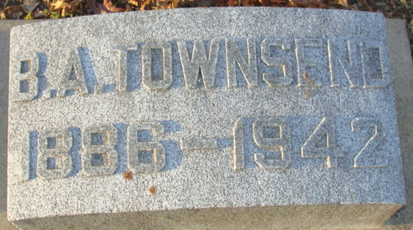
Photo by Alicia Kneuss

Burt Townsend
in the Indiana, U.S., Death Certificates, 1899-2017
Name Burt Townsend
Gender Male
Race White
Marital Status Married
Age 55
Birth Date 4 Nov 1886
Birth Place Decatur, Indiana
Death Date 2 May 1942
Death Place Decatur, Adams, Indiana, USA
Death Registration Date 1942
Father Dick Townsend
Mother Jessie L. Allison
Spouse Ruth Parsons
Informant Mrs. Burt Townsend; Decatur, Indiana
Burial May 4, 1942; Decatur Cemetery; Decatur, Indiana

