William E. Tou Velle
September 29, 1924 – April 15, 2011

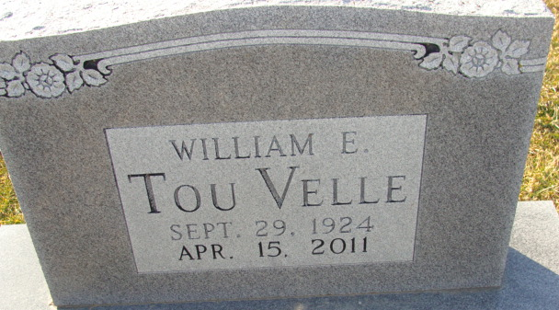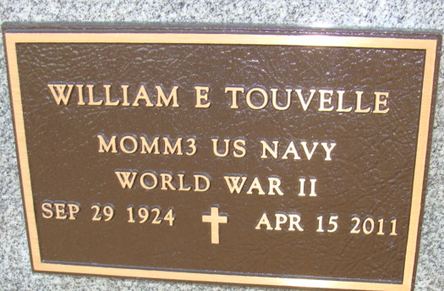
Photo by Alicia Kneuss

William E. TouVelle, 86 years old of Berne, Indiana, passed away at 9:42 p.m. on Friday, April 15, 2011, in the New Haven Care and Rehabilitation Center in New Haven, Indian where he had been a patient for the past month. William was born on Monday, September 29, 1924 in Columbus, Ohio, the son of the late Robert Day TouVelle and the late Lucille (Westonhaver) TouVelee.
William served in the United States Navy during World War II. William was an active member of the A.A. for many years. William was employed in sales for the Oxford Chemical Company for approximately 30 years.
Surviving are his son, Thomas S. TouVelle of Modesto, California; son, William H. TouVelle of Venice, California; sister, Cynthia (husband Sherry) TouVelle Hickman of Ohio; and two grandchildren.
Preceding William in death was one brother, Robert TouVelle.
Funeral services will be held at 11:00 a.m. Thursday, April 21, 2011 in the Zwick & Jahn Funeral Home with Richard Lambert officiating. Interment will follow in the Decatur Cemetery, Decatur, Indiana. Military Graveside Services will be conducted by Adams County American Legion Post #43 Color Guard. Friends will be received from 9:00 a.m. - 11:00 a.m. Thursday, April 21, 2011 in the Zwick and Jahn Funeral Home, Decatur, Indiana.
Preferred memorials are to American Legion Color Guard or Heartland Hospice Care.

Zwick & Jahn Funeral Home, Adams County, Indiana

