Robert D. Tope
June 16, 1917 – May 9, 1944

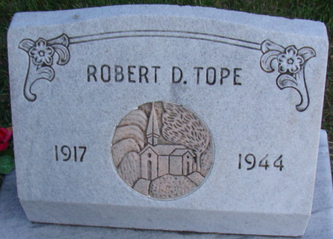
Photo by Alicia Kneuss

Robert Tope, 26, of Decatur, Ind., died at 6:30 a.m. Tuesday at his home, according to word received by his uncle, Gerald E. Welker, of 1425 Rice Av. Tope had been a frequent Lima visitor.
He is survived by his widow, two daughters and his parents, Mr. and Mrs. Groce Tope of Decatur, Ill.

Lima News, Allen County, Ohio
May 9, 1944
**
TOPE, Robert - Funeral services will be held at 3 p.m. (EWT) Thursday in U. B. Church, Bobo, Ind.

Lima News, Allen County, Ohio
May 10, 1944
**

Indiana, U.S., Death Certificates, 1899-2011
Name: Robert D Tope
Gender: Male
Race: White
Age: 26y 10m 23d
Marital status: Married
Birth Date: 16 Jun 1917
Birth Place: Van Wert Co, Ohio
Death Date: 9 May 1944
Death Place: Decatur, Adams, Indiana, USA
Father: Groce Tope, b. Van Wert Co, OH, informant
Mother: Mae Welker, b. Wells Co, IN
Spouse: Mary Girod, age 22 yrs
Burial: 5/11/1944 Decatur Cemetery

