Groce William Tope
November 26, 1896 – June 23, 1956

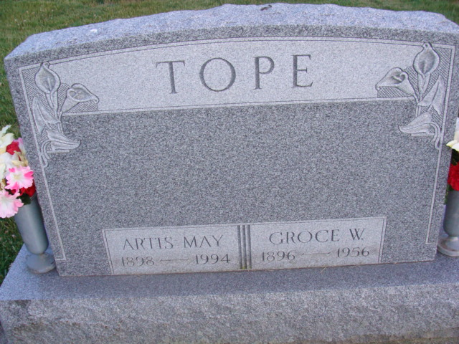
Photo by Deb Curry

Groce Tope, 59, for 40 years a resident of St. Mary's Township, died unexpectedly at 3:45 p.m. Saturday at his home, six miles southeast of Decatur, after he suffered a heart attack.
Mr. Tope was born November 25, 1896, near Wren, the son of Melville and Mary Ellen (Woods) Tope. He was married February 24, 1917 to May Welker, who survives.
He was the grandfather of Joyce Sue and Dixie Lea Tope of Van Wert, daughters of the late Robert Tope. Also surviving are a daughter, Mrs. Walter Winteregg, Highland, Ind., and a sister, Mrs. Clarence Fegley, Rockford.
Mr. Tope was an employee of the General Electric plant at Decatur and was a member of the Rockford Eagles Lodge and the Bobo Evangelical United Brethren Church.
Funeral services, with the Zwick Funeral Homes of Decatur in charge will be held at 1:30 p.m. Tuesday at the residence and at 2 p.m. at the Bobo Church, with Rev. Carlyle Seiple and Rev. L. A. Meddaugh officiating. Burial will be in the Decatur Cemetery.
Friends may call at the residence.

Van Wert Times Bulletin, Van Wert County, Ohio
Monday, June 25, 1956

