Ernst J. Tope
March 8, 1892 – January 12, 1946

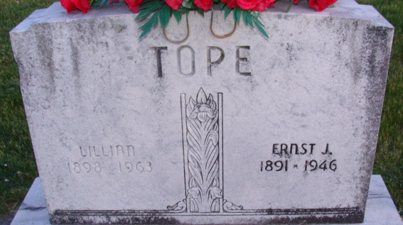
Photo by Alicia Kneuss

Earnest J Tape
in the Indiana, U.S., Death Certificates, 1899-2017
Name Earnest J Tope
Gender Male
Race White
Marital Status Married
Age 54
Birth Date 8 Mar 1892
Birth Place Van Wert County, Ohio
Death Date 12 Jan 1946
Death Place Decatur, Adams, Indiana, USA
Death Registration Date 1946
Father Melvill Tope
Mother Mary Ellen Woods
Spouse Lillian Robinson; age 50
Informant Mrs. Earnest Tope; Decatur, Indiana
Burial January 12, 1946; Decatur Cemetery; Decatur, Indiana

