Ernest Richard Tope
June 13, 1953 – August 30, 2011

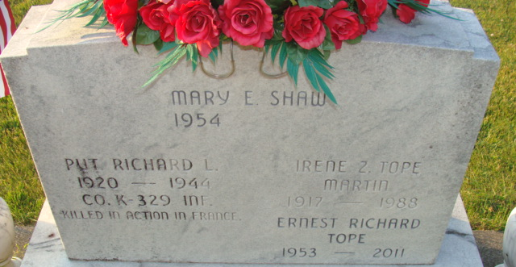
Photo by Alicia Kneuss

Tope Dies in Prison at Age 58
Ernest R. "Dick" Tope, a former Decatur resident serving a life sentence for the 1974 murder of a Van Wert County, Ohio, teenager, has died in prison.
Tope, 58, died of lung cancer last week in Pendleton Correctional Facility in central Indiana, according to a report in Thursday's Van Wert Times-Bulletin. Tope was convicted in the abduction, rape and murder of 19-year-old Cheryl Felger in Van Wert County on Good Friday of 1974.
Tope, 21 years old at the time, was accompanied by Timothy Allen Heckert of Decatur. According to The Times-Bulletin's account of the crime, Felger was lured into Heckert's car and driven across the state line, where she was raped by both men. Her body was found at a location south of Decatur. Heckert testified at the trial, held in the Allen County (Indiana) Circuit Court, that while both men raped the girl, it was Tope who
killed her. The autopsy report showed Felger has sustained more than 90 stab wounds.
Heckert was released years ago.
Tope, who had earned a law degree while in prison, had been denied parole numerous times over the past 30 years as area residents circulated petitions urging the parole board to deny those requests.
The Van Wert newspaper reported that Tope was sent to Wishard Hospital in Indianapolis on Aug. 22 and was returned to the Pendleton facility one week later. He died Aug. 30.
Decatur Daily Democrat, Adams County, Indiana
Saturday, September 10, 2011

**
Ernest Richard Tope
in the Indiana, U.S., Death Certificates, 1899-2017
Name Ernest Richard Tope
Gender Male
Race White
Marital Status Divorced
Age 58
Birth Date 13 Jun 1953
Birth Place Decatur, Indiana
Death Date 30 Aug 2011
Death Place New Castle, Henry, Indiana, USA
Death Registration Date 2011
Father Everett H Dye
Mother Irene (Tope) Martin
Informant Mike Smith; Exec. Assistant; New Castle, Indiana
Cremation Eastern Indiana Crematory; Lewisville, Indiana

