Artis May (Welker) Tope
January 4, 1898 – February 24, 1994

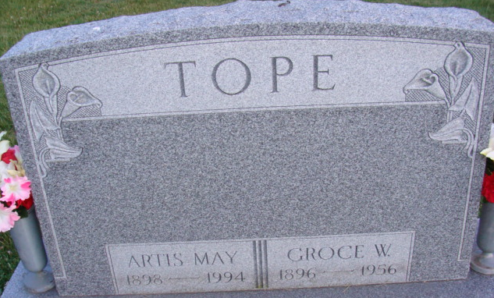
Photo by Alicia Kneuss

A. May Tope, 96, of Decatur died Thursday in Lakeside Manor Nursing Home, Decatur. The Adams County native was a homemaker and previous employee of Adams County Memorial Hospital and General Electric. She was the widow of Groce William, who died in 1956.
Surviving are her daughter, Mary Weber of Decatur; three grandchildren; eight great-grandchildren; two step-great-grandchildren; seven great-great- grandchildren; and six step-great-great-grandchildren.
Services are 11 a.m. Monday in Zwick-Sefton & Jahn Funeral Home, where calling is from 11 a.m. to 5 p.m. and 7 to 9 p.m. tomorrow. Burial will be in Decatur Cemetery.
Preferred memorials are gifts to Mount Zion United Brethren or the St. Mark's United Methodist Church.
News-Sentinel, Allen County, Indiana
Saturday, February 26, 1994
**
Indiana, U.S., Death Certificates, 1899-2017
Name Artis May Tope
[Artis May Welker]
Gender Female
Race White
Marital Status Widowed
Age 96
Birth Date 4 Jan 1898
Birth Place Decatur, Indiana
Death Date 24 Feb 1994
Death Place Decatur, Adams, Indiana, USA
Father S T Welker
Mother Sarah Catherine Chronister
Informant Mary Weber; daughter; Decatur, Indiana
Burial February 28, 1994; Decatur Cemetery; Decatur, Indiana

