Sharon Ruth Tonner
September 6, 2006 – January 8, 2011

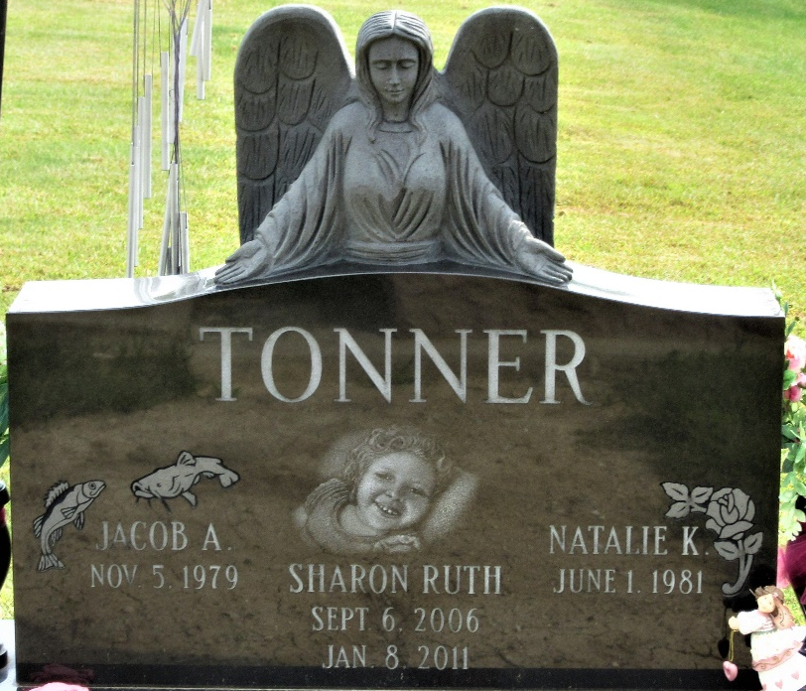
Photo by PLS

Sharon Ruth Tonner, four, of Decatur, went home to be with the Lord on Saturday January 8, 2011, at her residence. Her beautiful smile and wonderful laugh will be missed, but she can finally run and play like she always wanted to.
Sharon was born on September 6, 2006 to Jacob A. and Natalie (Winans) Tonner.
She is also survived by one brother, Jacob Daniel Tonner, and one sister, Breanna Sue Tonner, both at home; maternal grandparents Daniel E. and Pamela D. Winans of Decatur; paternal grandparents Sue Tonner of Decatur and Arlan Tonner of New Haven; great-grandparents John and Pat Parrish of Decatur and Ross and Rita Winans of Decatur; aunts and uncles Mrs. Tom (Tiffany M.) Rippe of Fort Wayne; Mrs. Jason (Julia) Krause of Connersville, Indiana; Mrs. Steve (Elicia) Oliver of Decatur; and Mrs. Rudy (Joanne) Nunez of Decatur; and several cousins.
Visitation will be on Tuesday, January 11, 2011, at Haggard and Sefton Funeral Home in Decatur from 3-7 p.m. and one hour prior to the services at Union Chapel United Methodist Church, rural Decatur. Funeral services will be held at Union Chapel United Methodist Church at 11 a.m. on Wednesday, January 12, 2011, with Pastor Ernie Suman officiating. Burial will be in Decatur Cemetery. Memorial contributions may be made to Family Hospice and Palliative Care of Northeast Indiana, in Berne.
Decatur Daily Democrat, Adams County, Indiana
Monday, January 10, 2011

