Natalie K. (Winans) Tonner
June 1, 1981 -

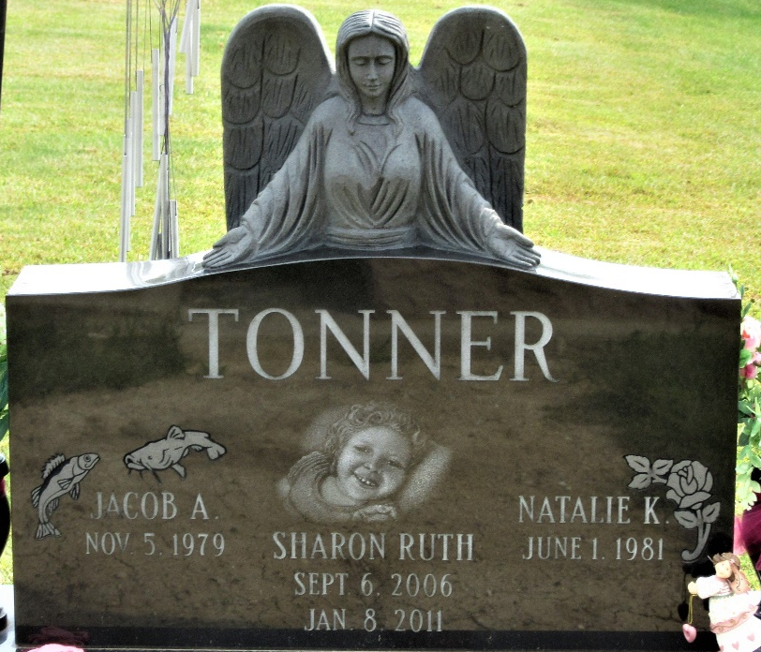
Photo by PLS

