Jacob A. Tonner
November 5, 1979 -

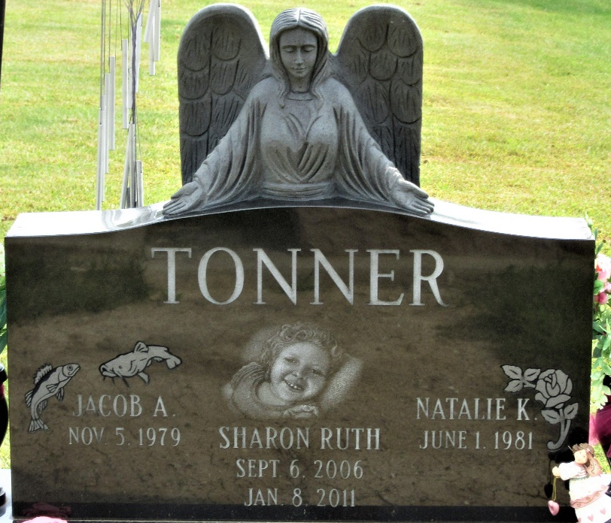
Photo by PLS

