Thomas Jacob Titus
August 3, 1861 – August 5, 1952

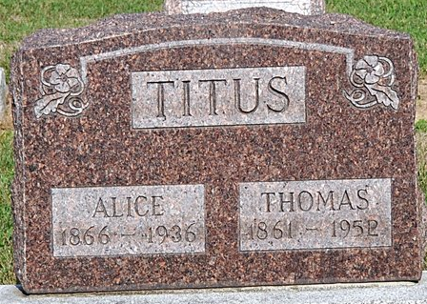
Photo by Deb Curry

Thomes Jacob Lites
in the Indiana, U.S., Death Certificates, 1899-2017
Name Thomes Jacob Titus
Gender Male
Race White
Marital Status Widowed
Age 91
Birth Date 3 Aug 1861
Birth Place Rush County, Indiana
Death Date 5 Aug 1952
Death Place Decatur, Adams, Indiana, USA
Death Registration Date 1952
Father Jesse Titus
Mother Sarah Jane Smith
Informant Mrs. Mary Hazelwood; Decatur, Indiana
Burial August 7, 1952; Decatur Cemetery; Decatur, Indiana

