Alice (Newton) Titus
January 17, 1866 – July 10, 1936

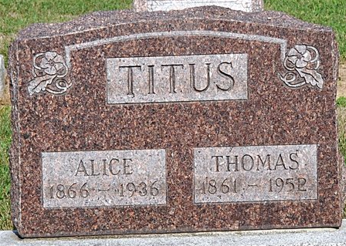
Photo by Deb Curry

Alice Titus
in the Indiana, U.S., Death Certificates, 1899-2017
Name Alice Titus
[Alice Newton]
Gender Female
Race White
Marital Status Married
Age 70
Birth Date 17 Jan 1866
Birth Place Concord Illinois
Death Date 10 Jul 1936
Death Place Washington, Adams, Indiana, USA
Death Registration Date 1936
Father Samiel Newton
Mother Martha Ellen Sims
Spouse Thomas Titus
Informant Mrs. Mary Hazelwood; Decatur, Indiana
Burial July 13, 1936; Decatur Cemetery

