Wilbur C. Tinkham
April 16, 1911 – December 3, 1991

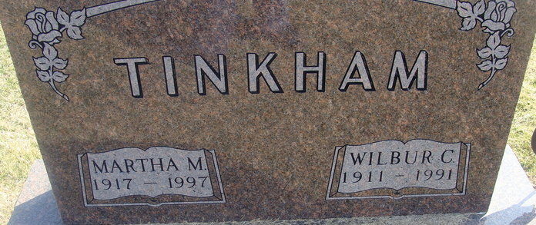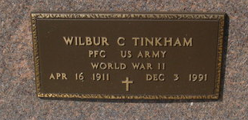
Photo by Alicia Kneuss

Wilbur C. Tinkham, 80, of Decatur died yesterday in Adams County Memorial Hospital.
He was a retiree of Central Soya and veteran of World War II.
Surviving are his wife, Martha; a sister, Etola Hill of Roanoke; and brothers, Melvin of Decatur and Herber of Muncie.
Services are 1 p.m. tomorrow in Haggard & Armes Funeral Home, Decatur, where calling is 2 to 5 and 7 to 9 p.m. today, with a Masonic memorial service at 7:30 p.m. and an Optimist Club memorial service at 9 p.m. Burial will be in Decatur Cemetery.
Preferred memorials are gifts to St. Mark United Methodist Church, Decatur.
News-Sentinel, Allen County, Indiana
Wednesday, December 4, 1991
**
Indiana, U.S., Death Certificates, 1899-2017
Name Wilbur C Tinkham
Gender Male
Race White
Marital Status Married
Age 80
Birth Date 16 Apr 1911
Birth Place Adams County, Indiana
Death Date 3 Dec 1991
Death Place Decatur, Adams, Indiana, USA
Death Registration Date 1991
Father Harvey C Tinkham
Mother Vernota Hakes
Spouse Martha Douglas
Informant Martha Tinkham; wife; Decatur, Indiana
Burial December 5, 1991; Decatur Cemetery; Decatur, Indiana

