Melvin H. Tinkham
October 9, 1923 – January 19, 2000

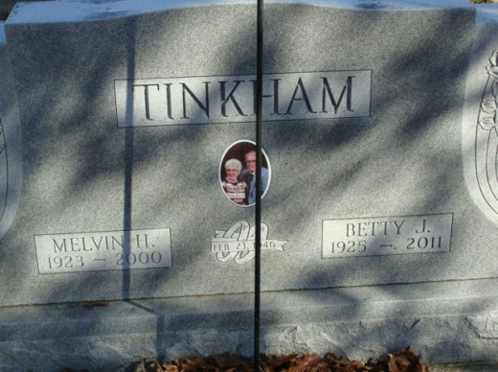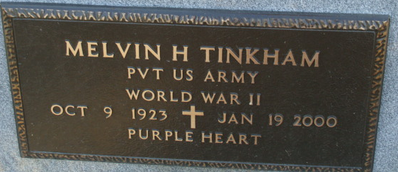
Photo by Alicia Kneuss

Melvin H. Tinkham, 76, of Decatur, a charter member of the Optimist Club, died Wednesday, Jan. 19, 2000, at Adams County Memorial Hospital.
The Adams County native retired in 1989 as owner of Mel Tinkham Insurance after 42 years of service, was a member of St. Mark's United Methodist Church where he served on several boards and as a trustee, American Legion Post 43, on the Decatur Cemetery Board and was a World War II Army veteran.
Surviving are his wife of 53 years, Betty J.; sons Van M. of Ogden, Utah, and Dr. P. Brad of Atlanta; a brother, Heber R. of Muncie; and two grandchildren. He was preceded in death by four brothers and a sister.
Services are 2 p.m. Sunday at Haggard & Sefton Funeral Home, Decatur, with calling from 10 a.m. to noon Sunday and also from 2 to 4 and 6 to 8 p.m. Saturday with a 7:45 p.m. Optimist service. Burial with military graveside services will be in Decatur Cemetery.
Memorials are to the church or the Decatur Optimist Scholarship Fund.

News-Sentinel, Allen County, Indiana
January 21, 2000

