Martha M. (Douglas) Tinkham
September 9, 1917 – October 15, 1997

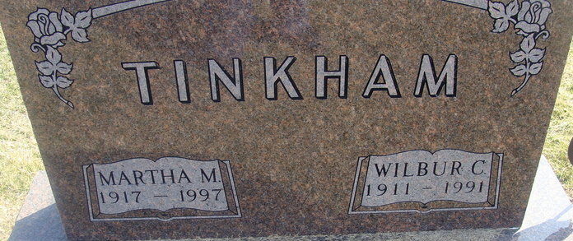
Photo by Alicia Kneuss

Martha M. Tinkham
in the Indiana, U.S., Death Certificates, 1899-2017
Name Martha M. Tinkham
[Martha M. Douglas]
Gender Female
Race White
Marital Status Widowed
Age 80
Birth Date 9 Sep 1917
Birth Place Adams County, Indiana
Death Date 15 Oct 1997
Death Place Decatur, Adams, Indiana, USA
Death Registration Date 1997
Father Augustus D. Douglas
Mother Nettie Sipe
Informant Alethia Martin; niece; Bryant, Indiana
Burial October 18, 1997; Decatur Cemetery; Decatur, Indiana

