Helen Agnes (Nyffeler) Tinkham
May 19, 1912 – May 3, 1960

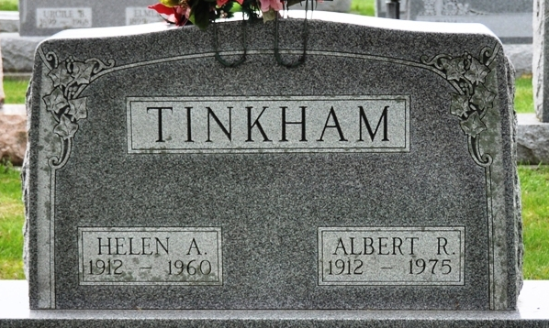
Photo by Deb Curry

Helen Agnes Tinkham
in the Indiana, U.S., Death Certificates, 1899-2017
Name Helen Agnes Tinkham
[Helen Agnes Nyffeler]
Gender Female
Race White
Marital Status Married
Age 47
Birth Date 19 May 1912
Birth Place Indiana
Death Date 3 May 1960
Death Place Decatur, Adams, Indiana, USA
Death Registration Date 1960
Father Charles Nyffeler
Mother Fannie Dutcher
Informant Albert Tinkham; husband; Decatur, Indiana
Burial May 6, 1960; Decatur Cemetery; Decatur, Indiana

