Betty J. (Werst) Tinkham
August 30, 1925 – April 26, 2011

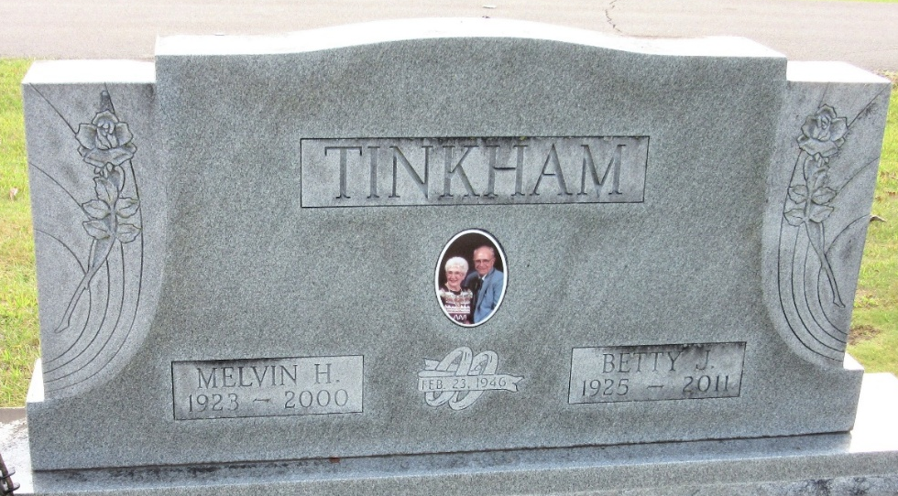
Photo by PLS

Betty J. Tinkham, 85 years old of Decatur, Indiana, passed away on Tuesday, April 26, 2011 in Adams Memorial Hospital.
She was born on Sunday, August 30, 1925 in Hoagland, Indiana the daughter of the late Rufus Werst and the late Hester (Young) Werst. She was married to Melvin H. Tinkham and he passed away in 2001.
She was a member of St. Mark's United Methodist Church in Decatur and was a homemaker.
Surviving are her son, Brad Tinkham M.D. of Atlanta, Georgia, son, Van (Denise) Tinkham of Ogden, Utah and two grandchildren; Evan Tinkham and Grant Tinkham.
Preceding Betty in death were four sisters; Maxine Werst, Eleanor Werst, Anna Werst & Luella Werst and four brothers; George, Jobe, Elmer & Ollie "Pete" Werst.
Funeral services will be held at 11:00 a.m. Saturday, April 30, 2011 in the Zwick & Jahn Funeral Home with Pastor Michael Heinbaugh officiating. Interment will follow in the Decatur Cemetery. Friends will be received from 2 to 6 p.m., Friday, April 29 in the Zwick & Jahn Funeral Home, Decatur and one hour prior to the service on Saturday at the funeral home.
Preferred memorials are to Adams County Community Foundation - Cancer Fund.
Zwick & Jahn Funeral Home, Adams County, Indiana

