Wilma Agnes (Harker) Tindall
September 6, 1897 – March 21, 1960

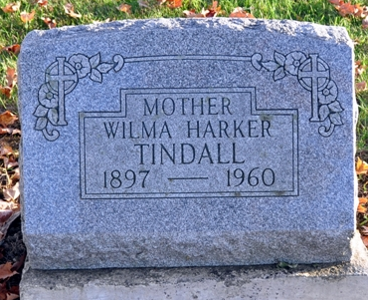
Photo by Deb Curry

Wilma Agnes Harker from tree Johnson Family Tree
Birth 6 Sep 1897 Harrison, Van Wert, Ohio, USA
Marriage 27 Sep 1922 Putnam, Ohio, USA
Residence 1 Apr 1940 Decatur, Adams, Indiana, USA
Death 21 Mar 1960 Grand Rapids, Kent, Michigan, USA
Father Jacob Fredrick Harker (1868-1949)
Mother Rebecca Ann McGill (1868-1910)
Spouse Sherman Virgil Taylor (1895-1971)
Spouse Elmer L Tindall (1896-1991)

