Otis E. Tindall
June 11, 1882 – August 15, 1910

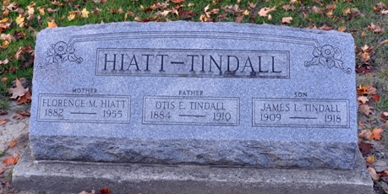
Photo by Deb Curry

Oti E Tindall
in the Indiana, U.S., Death Certificates, 1899-2017
Name Otis E Tindall
Gender Male
Race White
Marital Status Married
Age 28
Birth Date 11 Jun 1882
Birth Place Van Wert Co Ohio
Death Date 15 Aug 1910
Death Place Decatur, Adams, Indiana, USA
Death Registration Date 1910
Father William Tindall
Mother Catherine Lintermoot
Spouse Florence
Informant Mary E. W??; Indiana
Burial August 17, 1910; City Cemetery

