James L. Tindall
October 3, 1909 – June 8, 1918

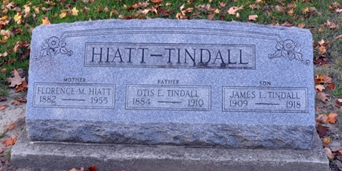
Photo by Deb Curry

James L Tindall
in the Indiana, U.S., Death Certificates, 1899-2017
Name James L Tindall
Gender Male
Race White
Marital Status Single
Age 8
Birth Date 3 Oct 1909
Birth Place Adams County
Death Date 8 Jun 1918
Death Place Pennville, Jay, Indiana, USA
Death Registration Date 1918
Father Otis E. Tindall
Mother Florence Woodard
Informant Florence Tindall; Pennville, Indiana
Burial June 10, 1918; Decatur, Adams County

