Florence May (Woodward) Tindall-Hiatt
April 18, 1882 – September 3, 1955

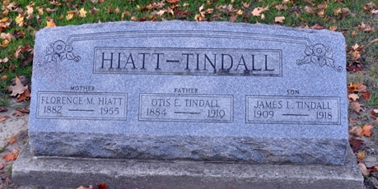
Photo by Deb Curry

Florence May Hiatt
in the Indiana, U.S., Death Certificates, 1899-2017
Name Florence May Hiatt
[Florence May Woodward]
Gender Female
Race White
Marital Status Married
Age 73
Birth Date 18 Apr 1882
Birth Place Adams County, Indiana
Death Date 3 Sep 1955
Death Place Pennville, Jay, Indiana, USA
Death Registration Date 1955
Father James Woodward
Mother Caroline Tetters
Informant Luther Hiatt; Portland, Indiana
Burial September 6, 1955; Decatur Cemetery; Decatur, Indiana

