Fern M. (Boday) Tindall
October 19, 1911 – June 6, 1972

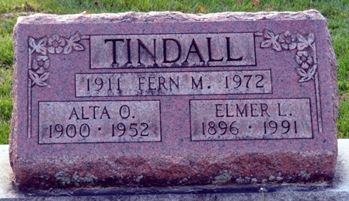
Photo by Deb Curry

MRS. FERN TINDALL
DECATUR – Mrs. Ralph Wiseman of Van Wert received notice of the death of her aunt, Mrs. Fern Tindall of Decatur. Mrs. Tindall died at her home at 5 p.m. Tuesday after a long illness.
She is survived by her husband, Elmer Tindall, two children and several grandchildren.
Funeral services will be at 10 a.m. Friday at the Winteregg-Linn Funeral Home in Decatur with burial in the Decatur Cemetery.
Van Wert Times Bulletin, Van Wert County, Ohio
Wednesday, June 7, 1972
**
Fern M. Tindall Taken by Death
Mrs. Fern M. Tindall, 60, died at 5:15 p.m. Tuesday at her home on Decatur route 6 following an extended illness. She was born Oct. 19, 1911, in Fostoria, O., a daughter of Mr. and Mrs. Adam Boday. Her first husband, Burton Wolfcale, died in 1939, and she was married Feb. 28, 1953, to Elmer L. Tindall, who survives.
Mrs. Tindall attended the Nuttman Avenue United Brethren church.
Surviving are the husband; a daughter, Mrs. Robert H. (Bertha) Finch of Cambridge, O.; one son, Richard Wolfcale of Decatur, Ill.; five sisters, one brother and five grandchildren. One brother is deceased.
Funeral services will be conducted at 10 a.m. Friday at the Winteregg-Linn Funeral Home, with Rev. Sylvester Martin officiating. Burial will be in the Decatur Cemetery. Friends may call at the funeral home after 1 p.m. Thursday until time of the services.

Decatur Daily Democrat, Adams County, Indiana
Wednesday, June 7, 1972

