Elmer Leroy Tindall
April 21, 1896 – January 30, 1991

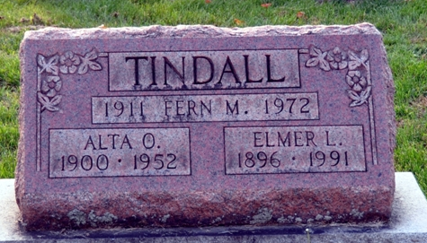
Photo by Deb Curry

Elmer L Tindall
in the Ohio, U.S., Death Records, 1908-1932, 1938-2022
Name Elmer L Tindall
Gender Male; Race White
Marital Status Widowed
Death Age 94
Birth Date 21 Apr 1896
Birth Place Indiana, USA
Residence Place Van Wert, Ohio, USA
Death Date 30 Jan 1991
Death Place Van Wert, Van Wert, Ohio, USA
Death Hospital Other/Nursing Home
Industry Railroads
Occupation Locomotive Operating Occupations
Filing Date 15 Feb 1991
Father Tindall
Certificate Number 014113
Inquest Hospital Long-Term Care Facilities
Inquest Questions Place of Injury: Unspecified Place; Injury in Ohio?: Yes; Referred to Coroner?: Not Referred to Coroner; Certifier: Physician; Autopsy Performed?: No Autopsy Performed; Time of Death: 09:00 Pm
**
Ohio, U.S., County Marriage Records, 1774-1993
Name Elmer Tindall
Gender Male
Marriage Age 21
Birth Date abt 1893
Marriage Date 17 Sep 1914
Marriage Place Mercer, Ohio, USA
Father Henry A. Tindall
Mother Sarah Presho
Spouse Grace Dryer
Film Number 000914959
**
Michigan, U.S., County Marriage Records, 1822-1940
Name Elmer Leroy Tindall
Gender Male
Age 23
Birth Date abt 1896
Marriage Date 12 Nov 1919
Marriage Place Kalamazoo, Michigan, USA
Father Henry A Tindall
Mother Sarah Tindall
Spouse Alma Edith Keller
Film Number 002108663
**

Ohio, U.S., County Marriage Records, 1774-1993
Name Elmer L Tindall
Gender Male
Marriage Age 26
Birth Date abt 1896
Marriage Date 27 Sep 1922
Marriage Place Putnam, Ohio, USA
Father Henry A Tindall
Mother Sarah A Preshoe
Spouse Wilma H Taylor
Film Number 001784634
**
Indiana, U.S., Marriage Certificates, 1960-2012
Name Elmer L. Tindall
Gender Male
Birth Place Wilshire, Ohio
Marriage Date 18 Oct 1975
Marriage Place Tilton, Jay, Indiana, USA
Spouse Fern Whetstone
Description Adams-Marion
Notes 2 N
Reference Number 1 Bx1446
Reference Number 2 Tr8598
Certificate Number 75-042393

