Alta Olivia (Brewer) Tindall
September 24, 1900 – January 3, 1952

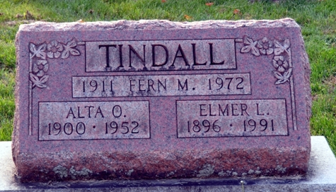
Photo by Deb Curry

Alta Olivia Brewer from tree SIV Family Tree
Birth 24 Sep 1900 Blanchester, Clinton, Ohio, USA
Marriage 1919
Residence 1950 Bellefontaine, Logan, Ohio, USA
Death 3 Jan 1952 Bellefontaine, Logan, Ohio, USA
Father Roy Brewer (Born 1880)
Mother Alice M Collins (1884-1921)
Spouse Elmer Leroy Tindall (1896-1991)

