Shirley A. Tickle
November 4, 1939 – March 9, 1998

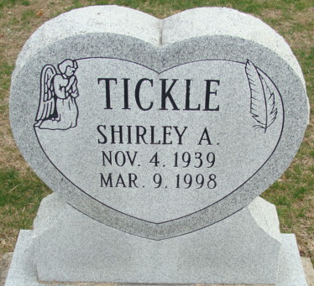
Photo by Alicia Kneuss

Shirley A Tickle
in the Ohio, U.S., Death Records, 1908-1932, 1938-2022
Name Shirley A Tickle
Gender Female; Race White
Marital Status Divorced
Death Age 58
Birth Date 4 Nov 1939
Birth Place Indiana, USA
Death Date 9 Mar 1998
Death Place Van Wert, Ohio, USA
Death Hospital Other/Residence
Military service No
Industry Own Home/At Home
Occupation Housewife/Homemaker
Education 12
Father [Robert] Tickle
Mother [Martha] Dull
Certificate Number 026907
Inquest Hospital Home
Inquest Questions Certifier: Coroner; Time of Death: 03:45 Pm

