Sheryl Kay Tickle
1947 – October 14, 1952

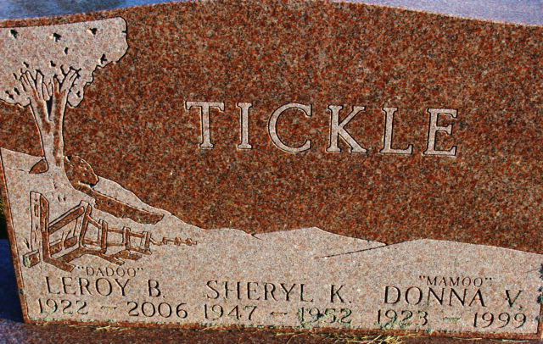
Photo by Alicia Kneuss

Sheryl Kay Tickle from tree TR Family Tree
Birth 1947 Indiana, USA
Residence 1950 Hardin, Marshall, Kentucky, USA
Death 14 Oct 1952 Ohio, USA
Father Leroy Brooks Tickle (1922-2006)
Mother Donna Virjean Kraft (1923-1999)

